Requirements and Design Specification Document

Enhancing GIFT University Website with Career Counseling Functionality
Introduction

Project Code:

Advisor:
Miss Aneeka Shayan

Project Team:
- Momna Asghar (221400110)
- Zerlish Burhan (221400111)
- Ahmad Shahzad (221400077)
- Muhmmad Hassan (221400086)

Submission Date:
12/08/2023

Document Information

Category | Information
Customer
Project | <Project Title>
Document | Requirement Specifications
Document Version | 1.0
Identifier
Status | Draft
Author(s) | Momna Asghar (221400110)  Zerlish Burhan (221400111)  Ahmad Shahzad (221400077)  Muhmmad Hassan (221400086)
Approver(s)
Issue Date
Document Location
Distribution

Definition of Terms, Acronyms and Abbreviations
This section should provide the definitions of all terms, acronyms, and abbreviations required to interpret the terms used in the document properly.

Term | Description

Table of Contents
1. Introduction 4
1.1 Purpose 4
1.2 Scope 4
1.3 Definitions, Acronyms, and Abbreviations 4
1.4 References 4
1.5 Overview 4
2. Overall Description 4
3. Specific Requirements 5
3.1 Functionality 5
<Functional Requirement One> 5
3.2 Usability 5
<Usability Requirement One> 5
3.3 Reliability 5
<Reliability Requirement One> 6
3.4 Performance 6
<Performance Requirement One> 6
3.5 Supportability 6
<Supportability Requirement One> 6
3.6 Design Constraints 6
<Design Constraint One..> 7
3.7 On-line User Documentation and Help System Requirements 7
3.8 Purchased Components 7
3.9 Interfaces 7
User Interfaces 7
Hardware Interfaces 7
Software Interfaces 7
Communications Interfaces 7
3.10 Licensing Requirements 7
3.11 Legal, Copyright, and Other Notices 7
3.12 Applicable Standards 7
4. System Architecture 8
5. Use Cases 8
5.1 Use Case Diagram 8
5.2 Use Case Description 8
6. Detailed System Design 9
7. Research and Development 9
8. Learning Outcomes 9
9. Practical Applications 9
10. Supporting Information 9

Introduction

Purpose
This website, GIFT University provides information about the institute to the public and students interested in pursuing further education. It provides its students with a
- Login panel through which the students can keep check of their university credentials.
- Their time schedule, and all their records throughout their stay at the university.
In our project, we will document how to add new functionality to the website that provides the students with their career counseling in real-time before they register, so they can apply to a program that satisfies them. The blog will only provide information about:
- All study fields
- Scope
- Job markets.
An AI will only respond to related questions about career counseling. If the AI cannot respond to any question asked by a student, it will direct the student to another chat where the student will be able to ask his questions to a university staff member who will respond to the asked question in a given amount of time. If the student is still not able to understand something clearly another functionality will enable the student to book an appointment with the career counseling staff at the university.

Scope
The blog will only provide information about all study fields, their scope, and their job market. The AI will not respond to unrelated questions. University staff members must respond to the asked question in the given time. The student will be able to book an appointment with the career counseling staff at the university.

References
https://www.gift.edu.pk/

Overview
The main purpose of this proposal is to provide students with career counseling so that they can choose a program that satisfies them. This proposal has no other purpose and performs no other function.

Functionality
- Users should be allowed to sign up for accounts using their school credentials.
- User accounts should be accessible after a successful registration.
- Users should be taken to a customized dashboard after logging in.
- The dashboard should display the user's time schedule, academic records, and other relevant information.
- Questions about study areas, scope, employment markets, and other career-related inquiries should be addressed by the chatbot.
- The website should have a blog section that provides comprehensive information about all study fields, their scope, and job markets.
- Users should be able to access this blog to make informed decisions about their academic choices.
- Users should be able to schedule one-on-one appointments with career counseling staff members.
- The appointment booking should provide available time slots and allow users to select their preferred timing.

Usability
- The user interface should be intuitive, easy to navigate, and visually appealing.
- Chatbot interactions should feel natural and engaging, providing helpful responses.
- To quickly respond to customer inquiries, the chatbot and staff member response systems should be highly available.

Reliability
- In order to allow for upgrades, bug corrections, and the inclusion of new features, the website should be maintainable.
- User data, including login credentials and personal information, should be securely stored and transmitted.

Performance
- The user interface should be intuitive, easy to navigate, and visually appealing.
- Chatbot interactions should feel natural and engaging, providing helpful responses.
- A rapid website load time will guarantee a smooth user experience.
- The chatbot's response time should be within a few seconds to keep user engagement high.

Supportability
- An AI-powered chatbot that can offer customers career counseling information should be available on the website.
- The website should be designed to accommodate users with disabilities, adhering to accessibility guidelines.
- Interactions with the chatbot should be friendly and helpful.

Design Constraints
The status of different programs may be changing according to market demands at times. So, the career counseling blog information should be updated regularly and checked to provide correct information. The university staff may not be available at all times to respond. So, the student should be able to schedule an appointment for when a member of the university staff is available.

Applicable Standards
The standard for the proposed feature of career counseling should be as follows:
- The information provided should be original. Meaning Information that is worked on by the university authorities.
- It should be updated regularly.
- The words used in the blog should be easily understandable by the students.
- The chatbot interaction should be friendly and understandable and satisfactory for the students.

System Architecture

UML Class Diagram

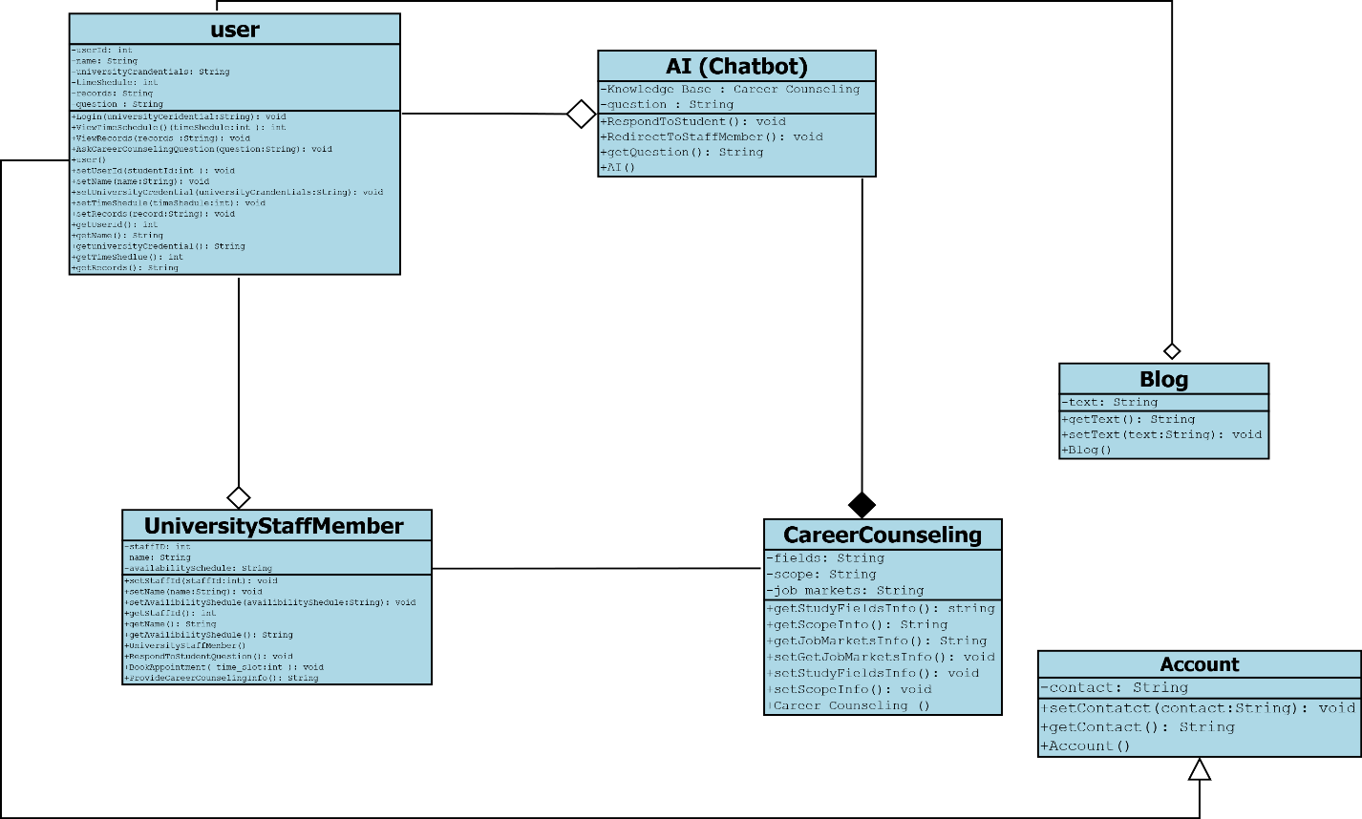

Sequence Diagram

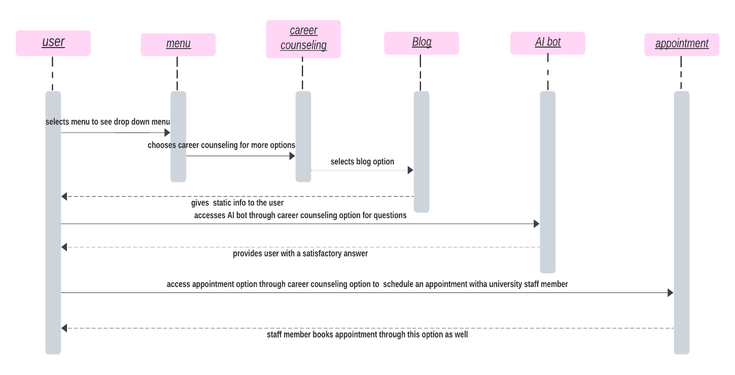
Entity Relationship Diagram (ERD)
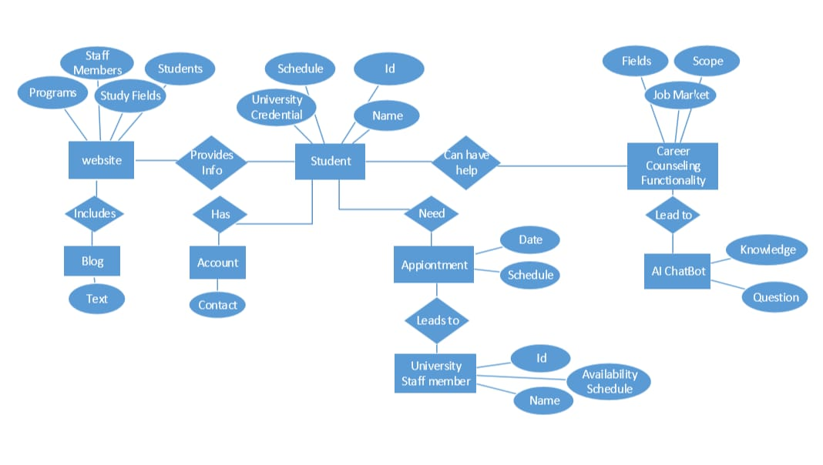
Use Case

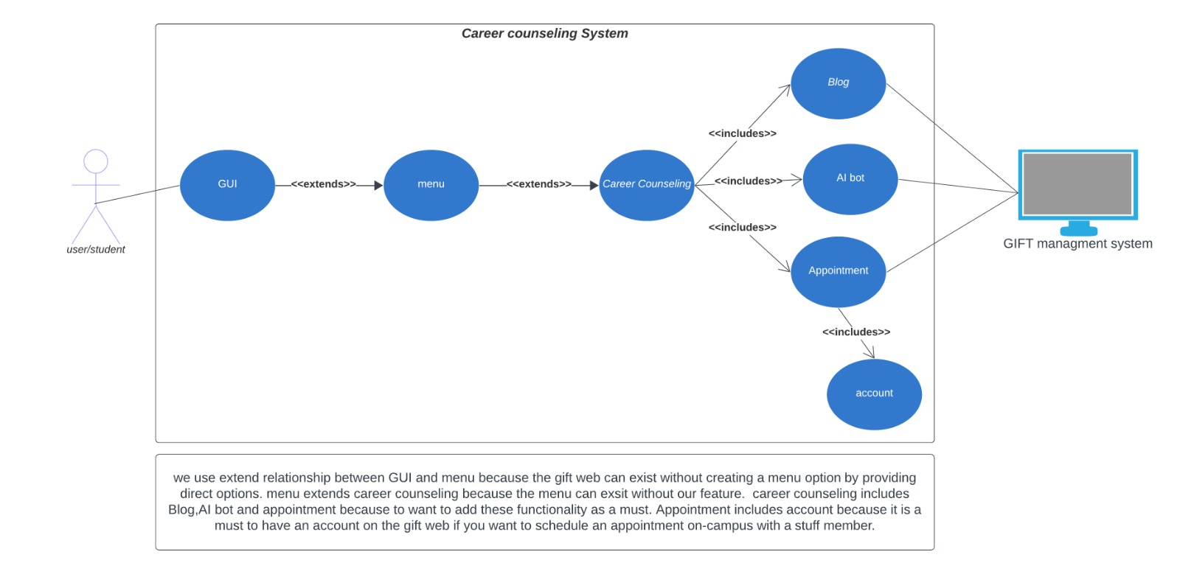
Prototype # 1:

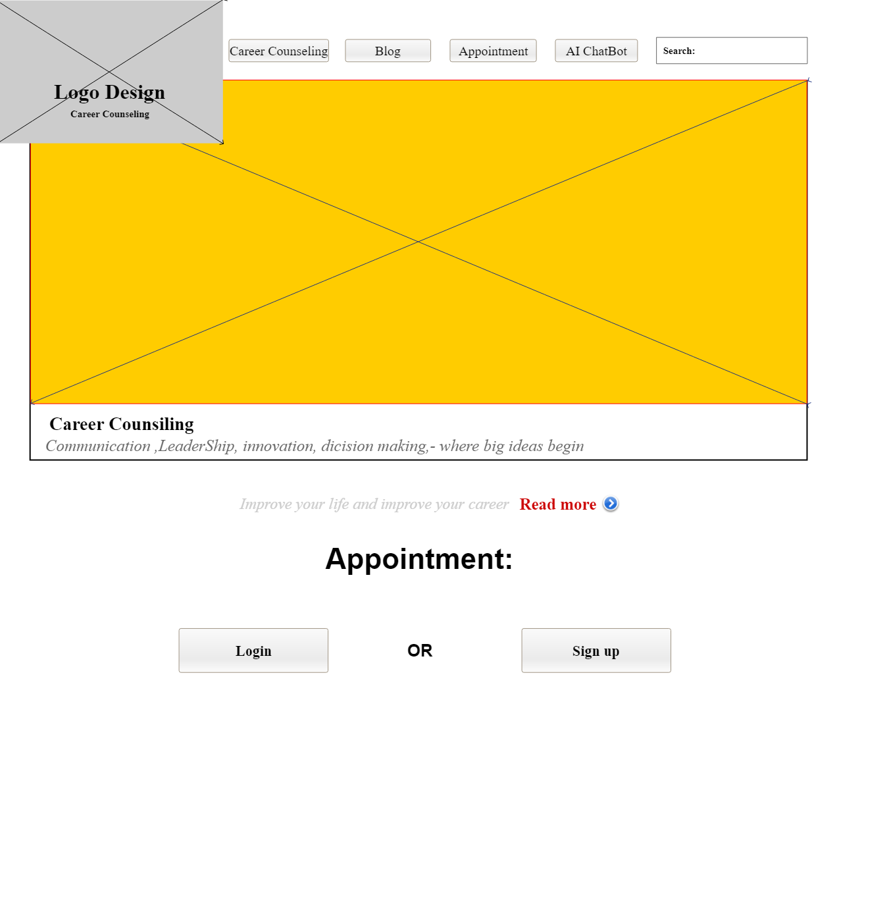
Prototype # 2:

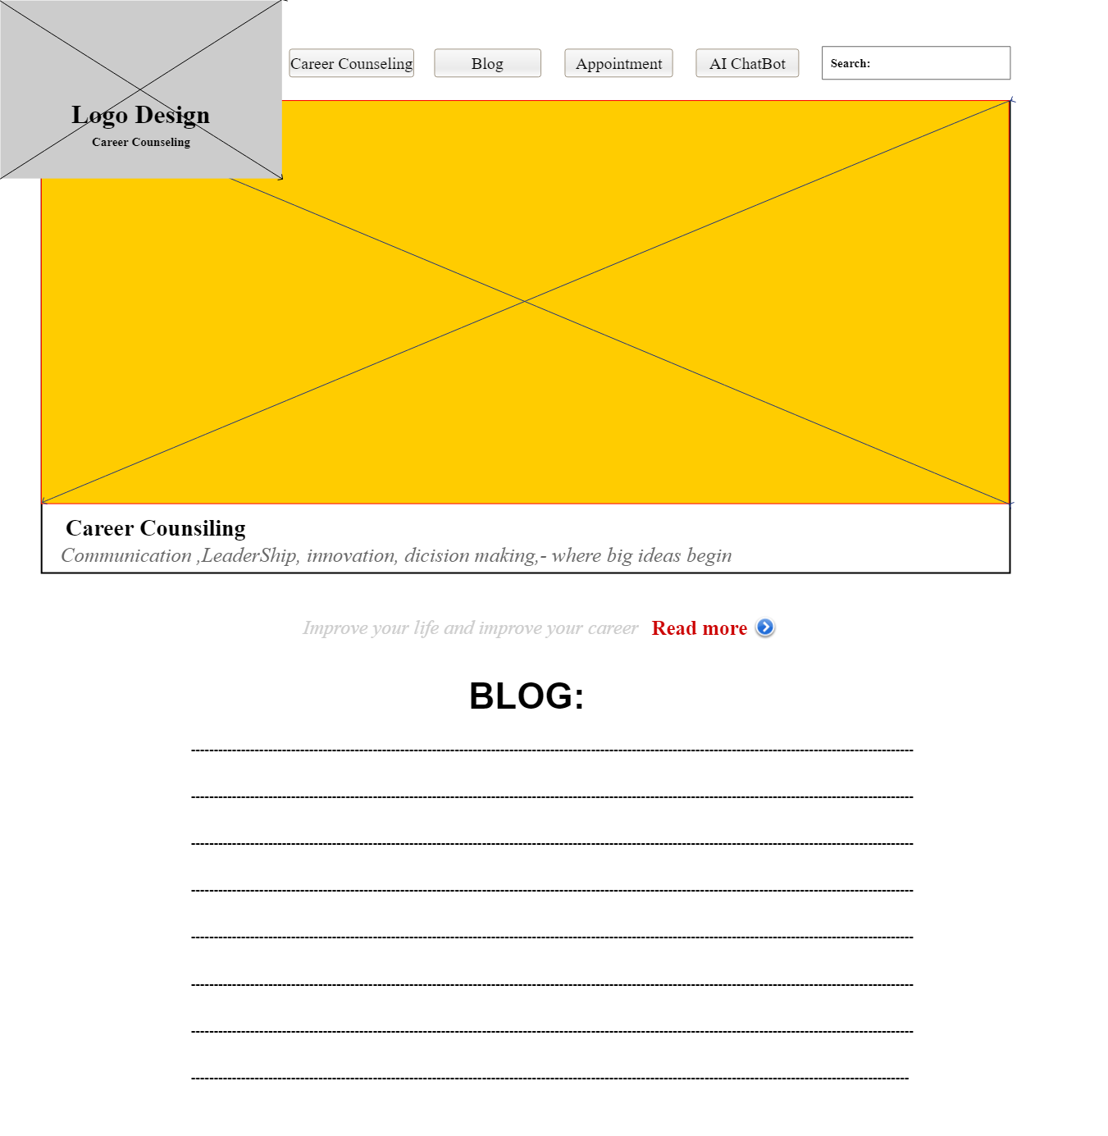

Prototype # 3:
